**TASKS:**

**1. Updation/Additional fields incorporated in the IMS System**

  The following fields were added in the respective tables and updated in the front

end.

1. Date of Issue of the registration
2. Date of Expiry   of the registration
3. Postal Address added with master list of Dzongkhag, Gewog  and Village
4. Contact details of the focal person’s CID is added and integrated with Census.
5. Board of Directors CID  is added and integrated with auto fetching of Name from the census.

**2. Renewal of CSOs Certificate and make payment online**

The process of renewing the registration Certificate of CSOs shall have the option to pay renewal fee online and get the auto-email notification reminding those CSOs nearing their expiry date before one month of their certificate for renewal date.

Information on the validity of the certificate is added as shown below;

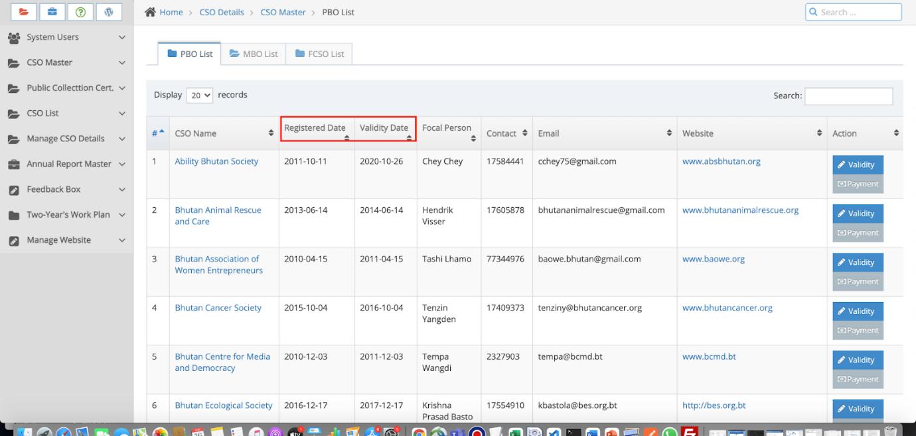

Added new fields to show the validity of the CSO certificates as shown below:

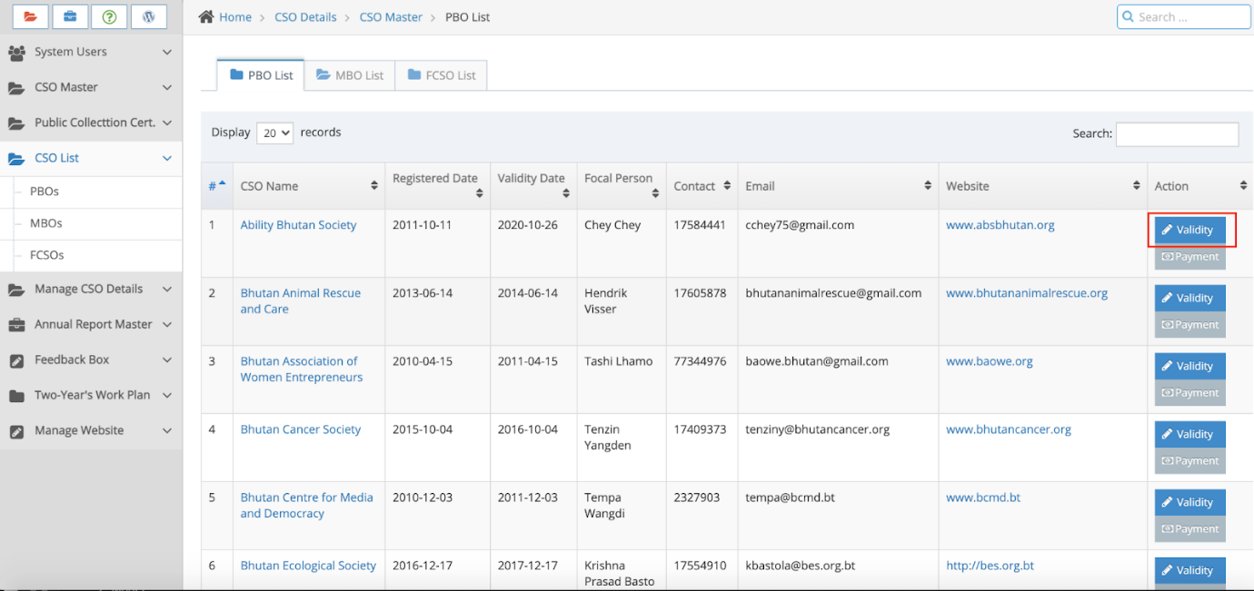

Also, information to update the validity of the certificate and see the pending payment. Payment will automatically calculate the normal prescribed fee along with due penalty (if any) as shown below.

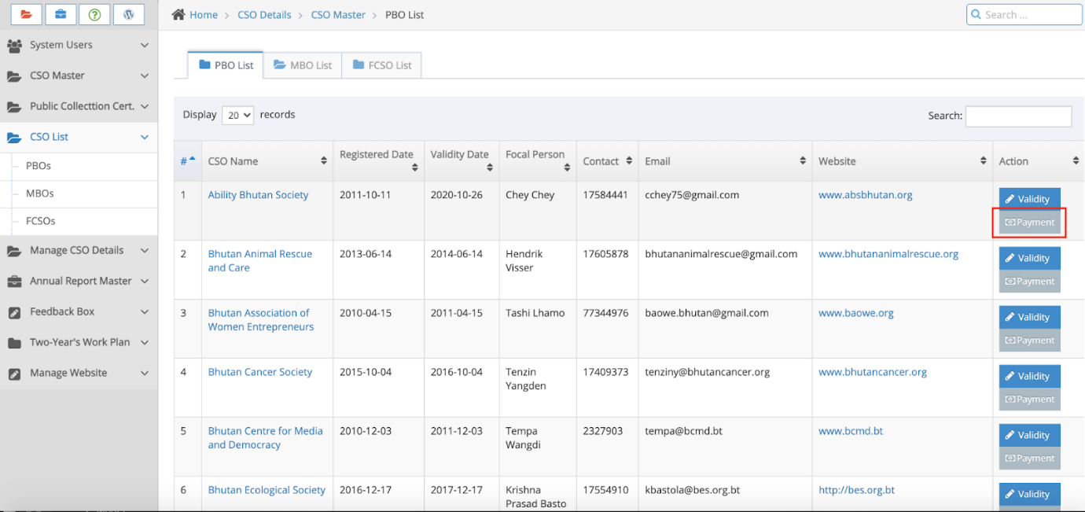

Payment is integrated with RMA payment gateway, and it will redirect to RMA payment gateway as shown below, when the CSO clicks to make online payment.

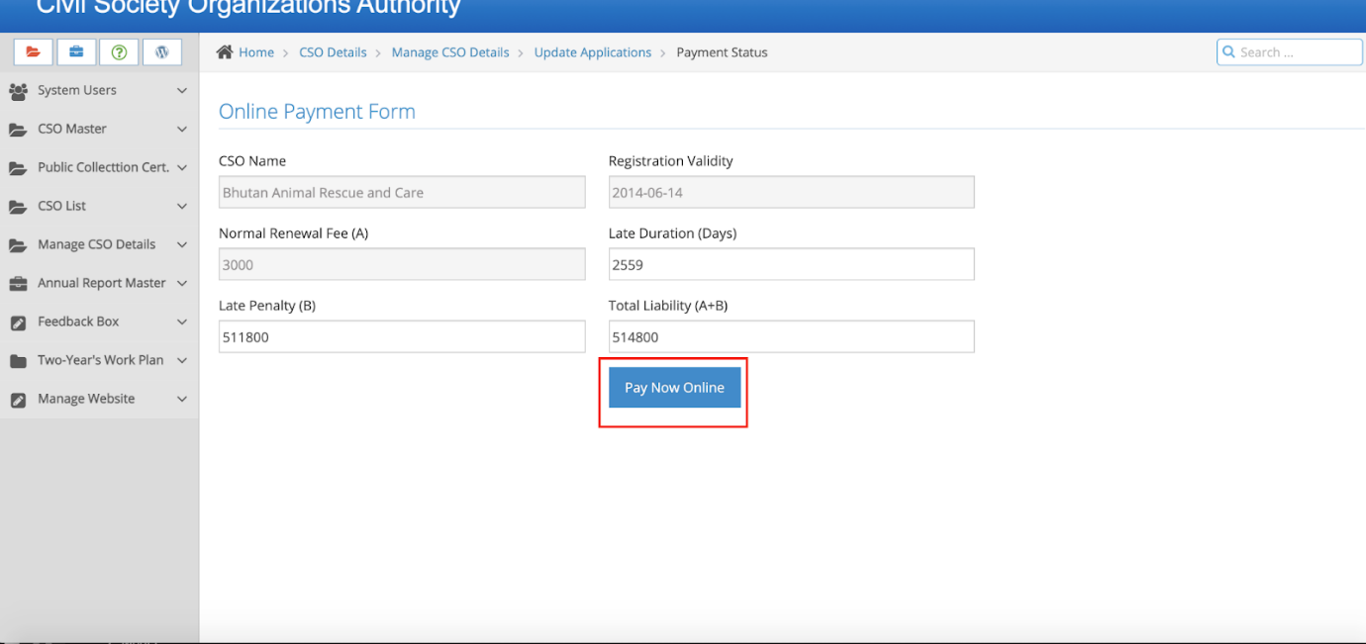

Clicking on the “Pay Now Online” will redirect to RMA payment gateway as shown below;

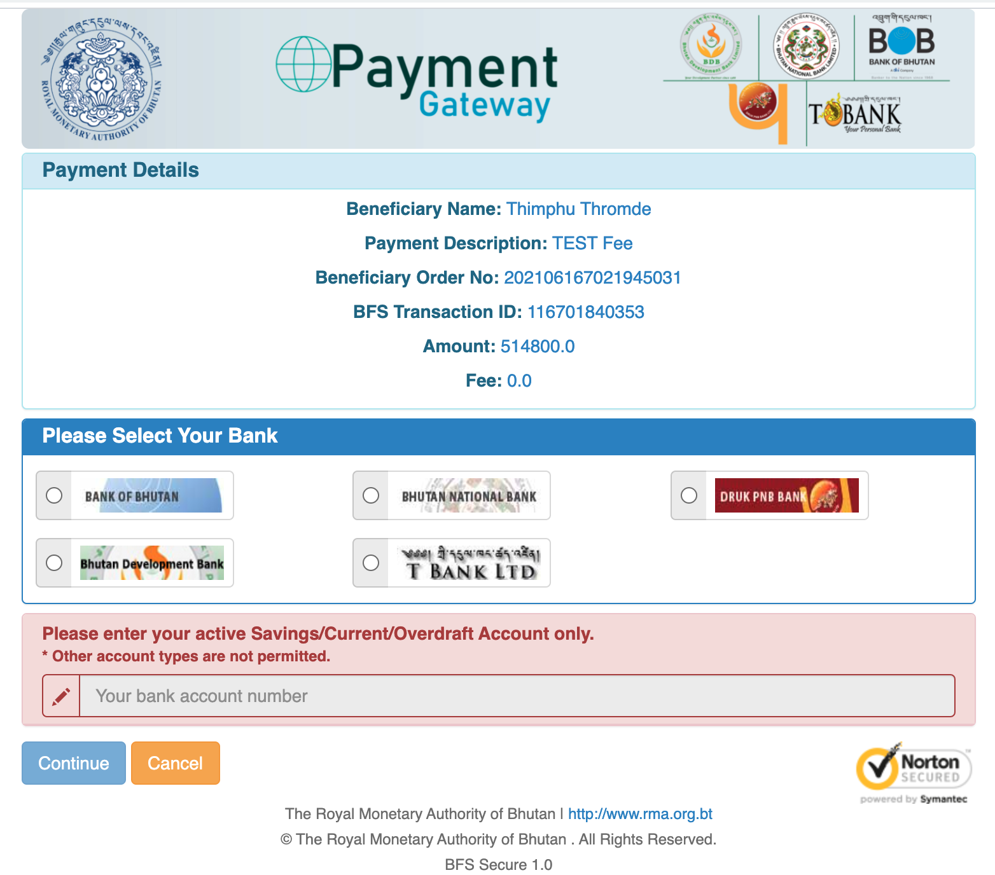

Users can choose the Bank and provide their account number and proceed to make the final payment. This mode of payment is secure, and will receive OTP from the bank.

Validity of the CSO can be updated from CSOA interface as shown below;

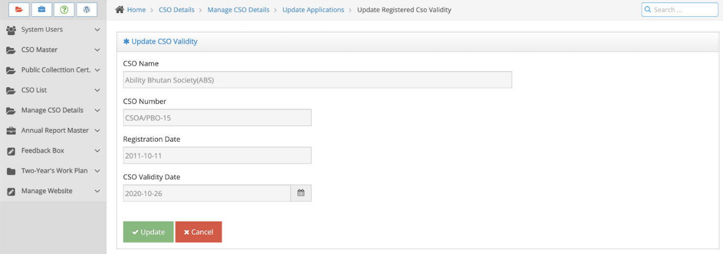

Added, Address details which has hierarchy of selection, added master data of Dzongkhag, Gewog and Village as shown below;

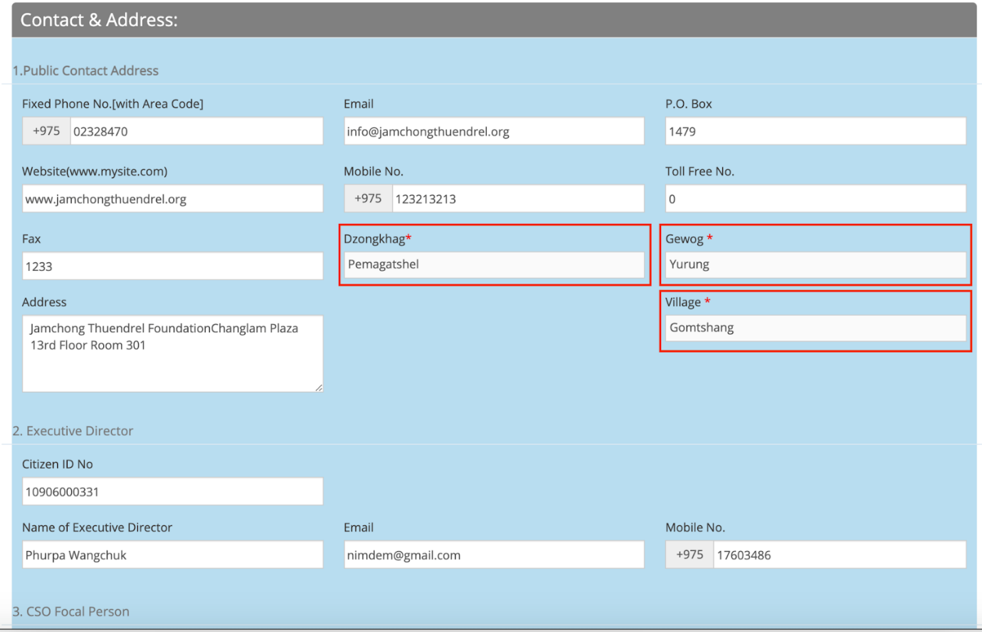

CID of the Executive Director and Focal is added, and it is integrated with census, which fetched the information automatically as shown below;

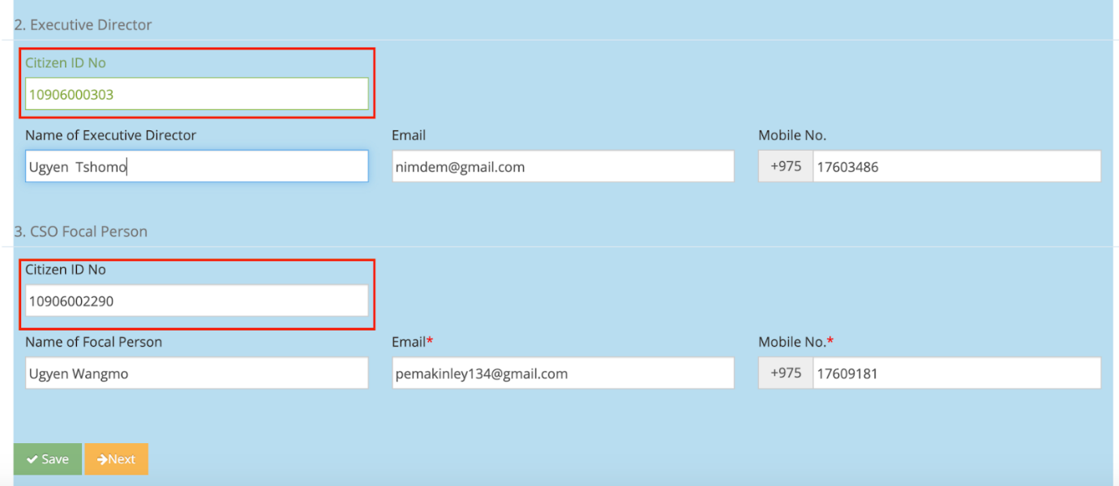

Added CID of the trustee and information is auto fetched from the Census as show below;

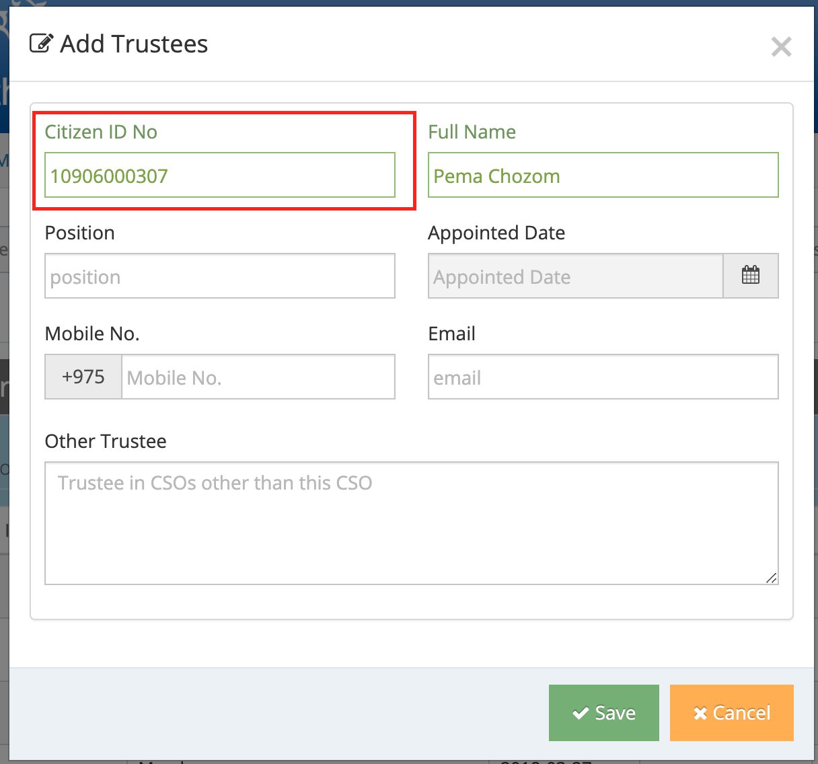

To see the payment report of the CSOA is added as shown below;

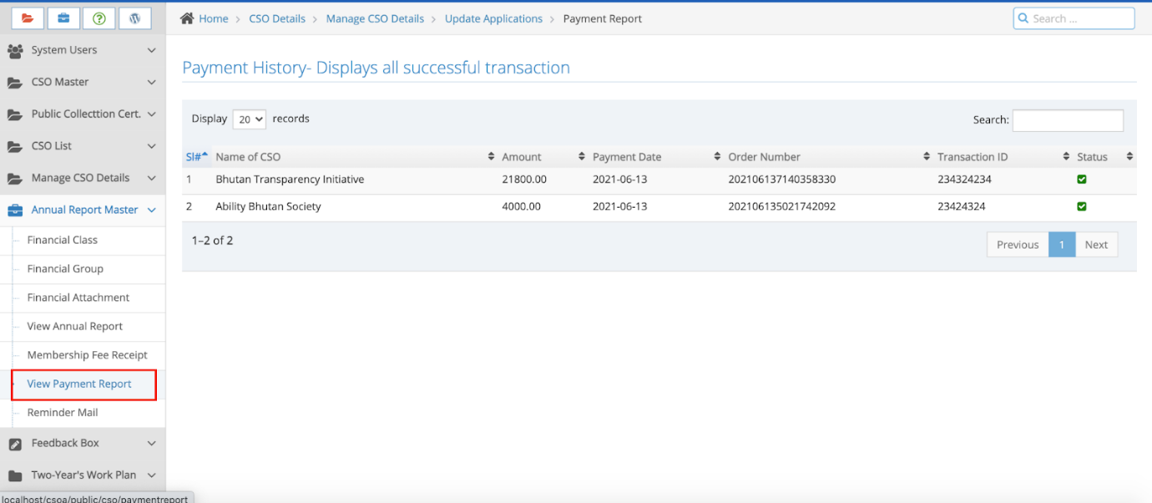

**Certificate View/Download;**

If the online payment is successful, then CSO can view and download the certificate in pdf format as shown below. Certificates are dynamic and information are fetched and displayed from the system.

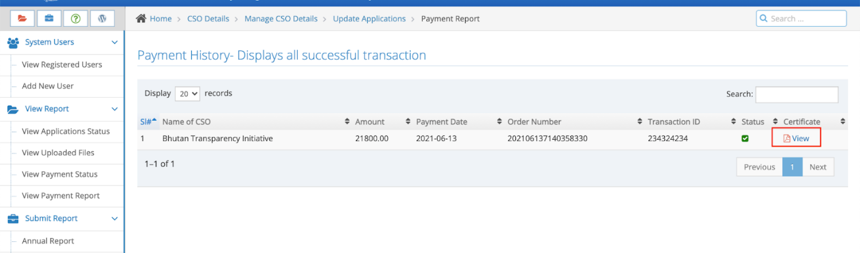

On clicking the above view certificate will display the content and to generate pdf, users have to click on download.

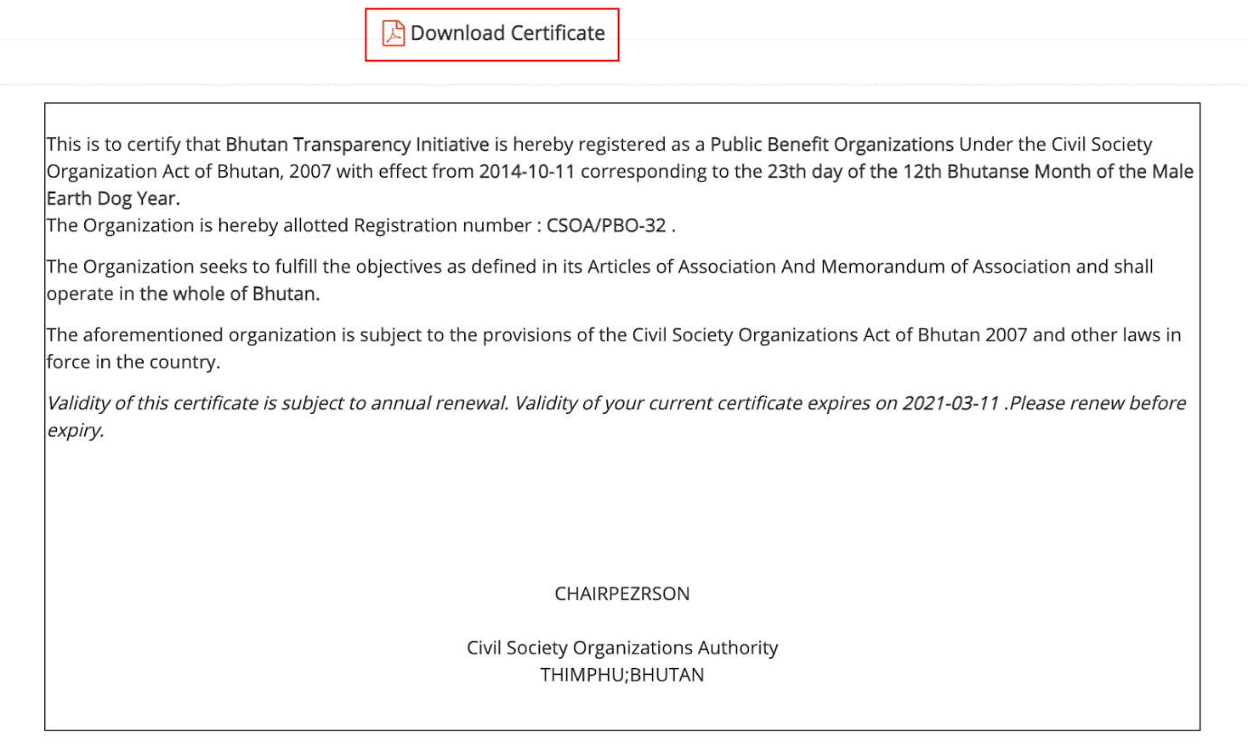

Sample of it from the system is attached below;

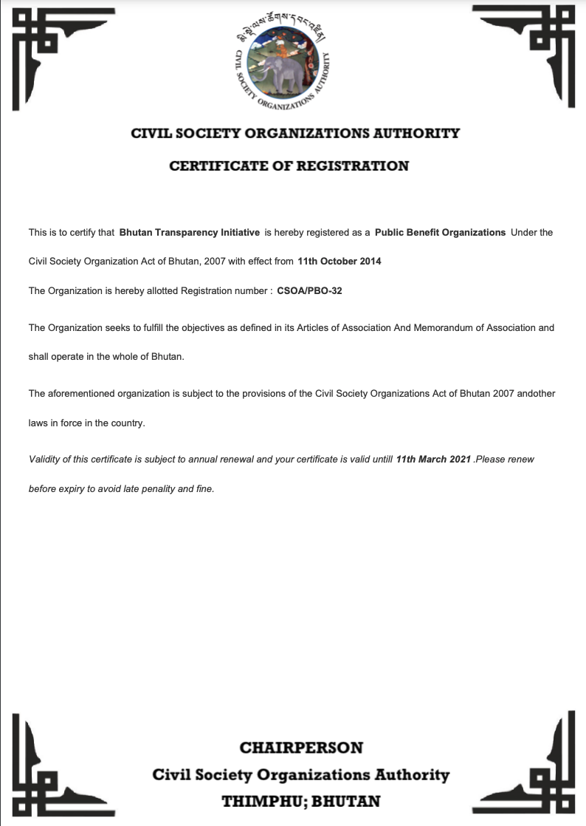

CSOA can collect Offline payment collection and update in the system as shown below;

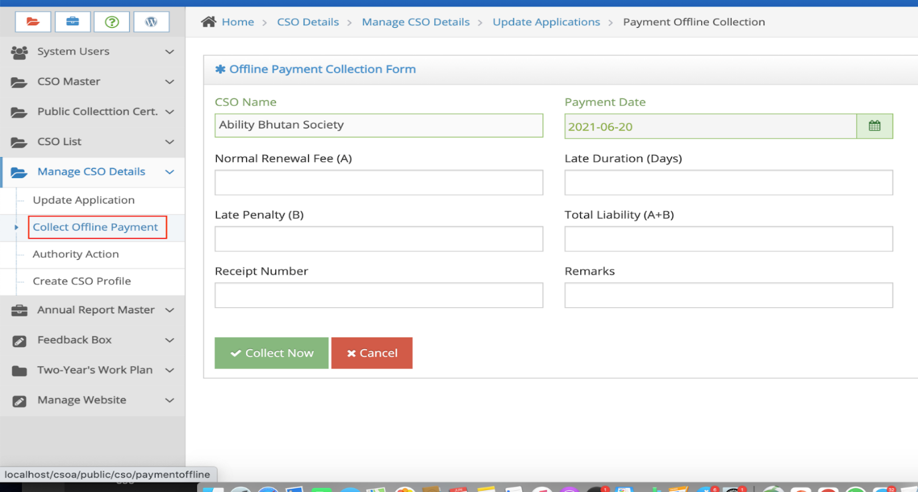

In CSAO dashboard, summary report of total payment collected and CSO validity summary report is incorporate as show below;

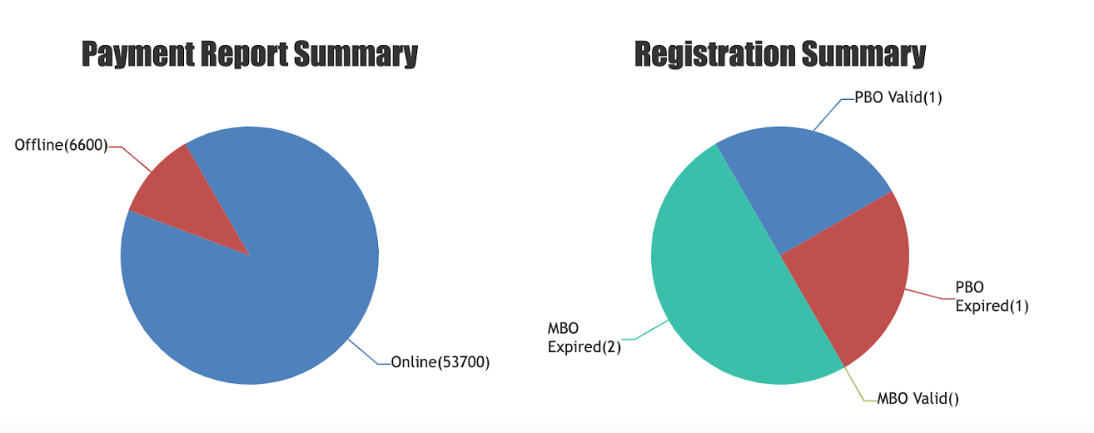

* API is developed

Other Penalty Notification Form

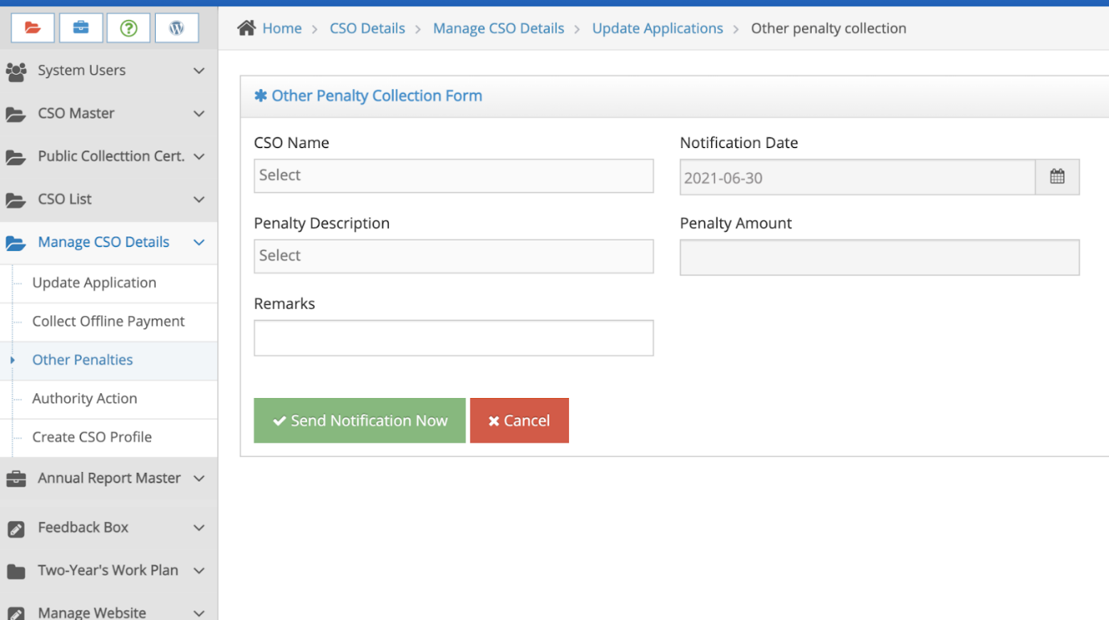

Added Status filed in the CSO list to see the status of the CSO. CSOA can update the status field and can give the reason for the deactivation of the CSO. The reasons for the deactivated CSO can be viewed by clicking the “Remarks” button. This  button can be seen only if CSO is inactive, as shown below;

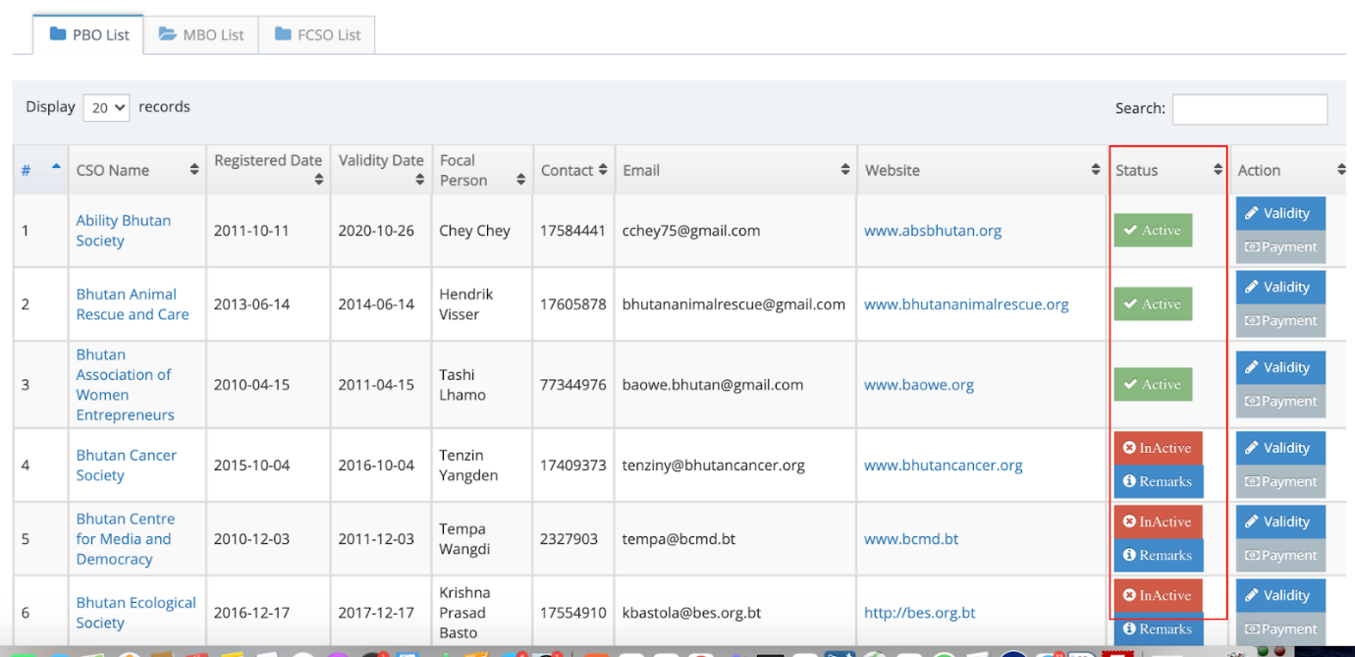

Aligned Logo center in the CSOA Login as shown below;

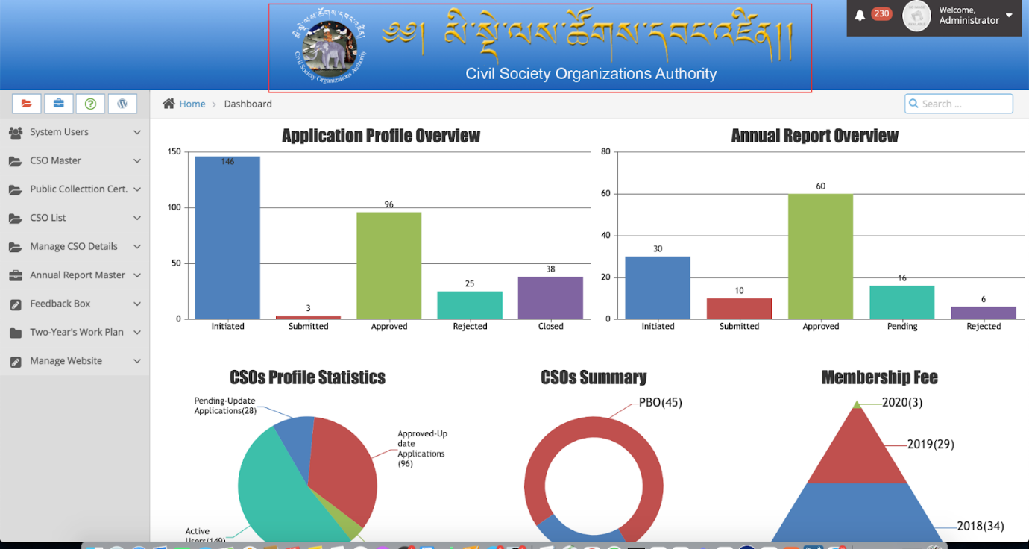

Status of the CSO is activated in the public domain, If the status is inactive then reason for it is shown on hovering the infomration icon as illustrated below;

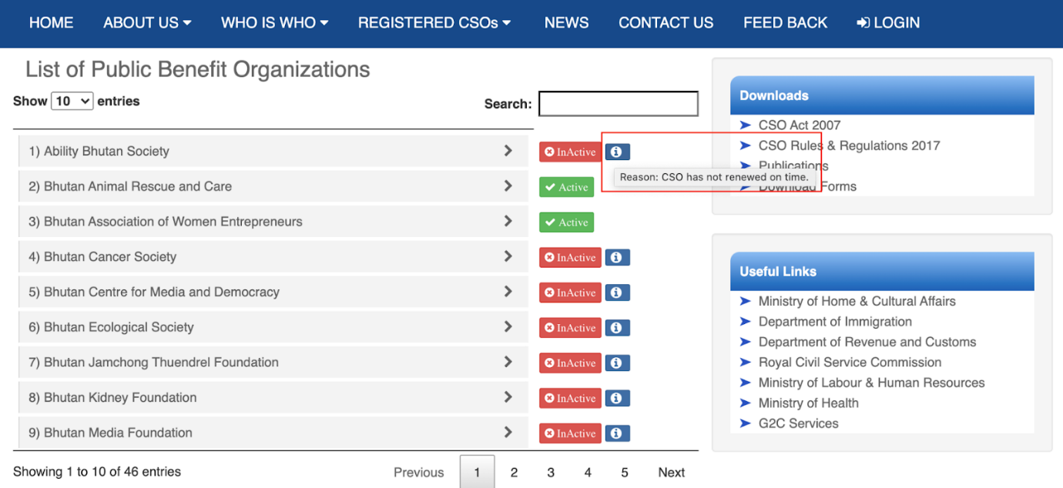

In the CSO interface, Income Statement and Balance sheet form is modified by removing unwanted fields and keeping only required fields as shown below;

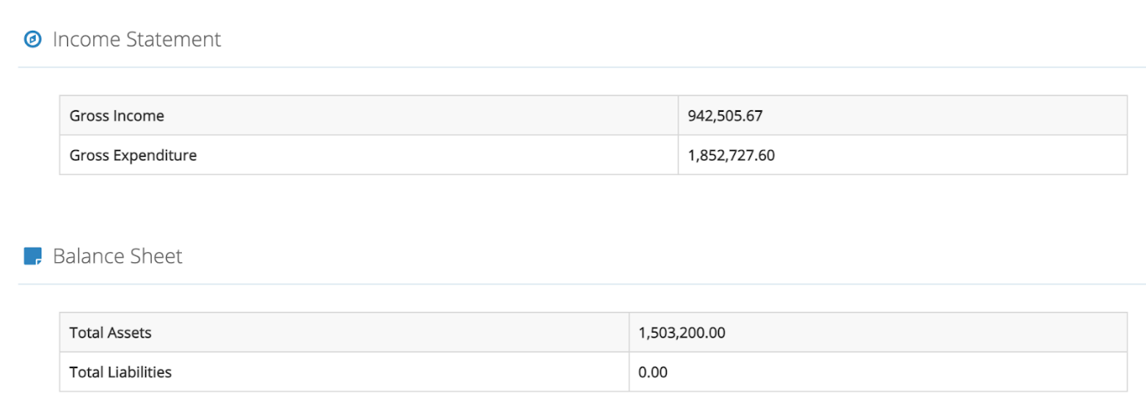

TO DO;

1. After application is approved for changes - then 500 to change and notification to make payment to add

**B. Additional Features**

**1. To show the Status of Active and Inactive CSOs to the CSOA Admin Users**

The Status of Active and Inactive CSOs should be published on the CSOA website to have access to CSOA Admins only.

 The status of the CSOs is determined by the validity of the CSOs Certificate for a period of one year subjected for renewal every year to retain their status of active CSO

Active CSOs are the ones, those who follow mandated compliance by submitting/uploading various kinds of reports as required by the CSO Act and   Regulation. Inactive CSOs are vice-versa.

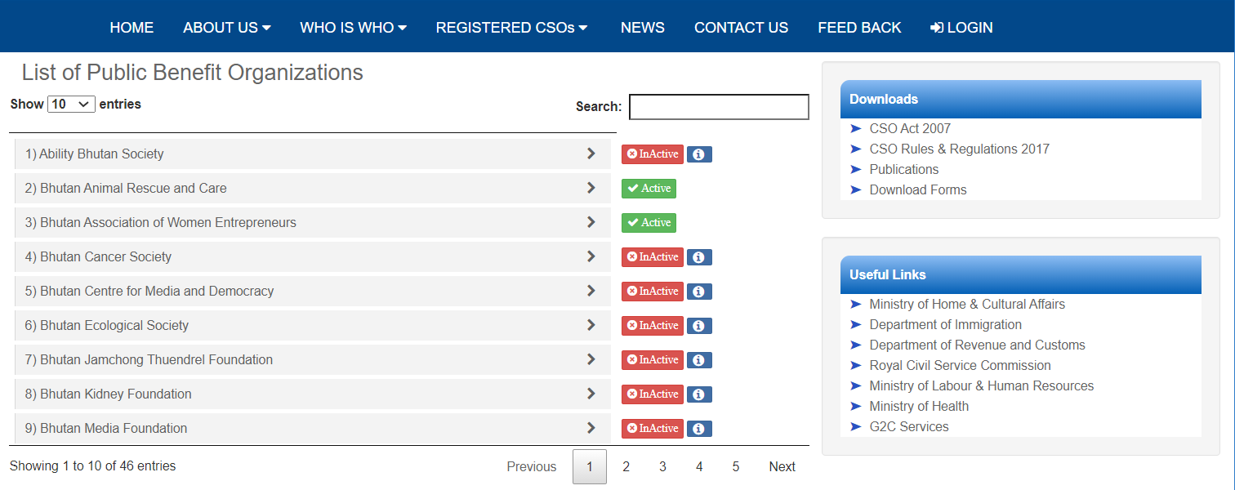

**2. Dashboard to view the status of the document submitted by the CSOs by CSOA**

 To show each documents submitted by the individual CSOs in the dashboard for renewal of registration certificate.

**A.**PBOs are mandated to submit Annual Report Comprise of (i) Audited Financial Statement (ii) Auditors Report (iii) Trustees Report and Annual Membership Renewal Fee Receipt

MBOs are required to submit (i) Minutes of Annual General Meeting (AGM) and (ii) Receipt of Annual Membership Renewal Fees

This status of uploaded documents will be used for monitoring purpose by the CSOA.

**3. Payment Report**

Report for the online payment and off-line payment will be made available to the CSOs and CSOA admins